A Project Report

On

“Hospital Management System”

Submitted By

Thakarda Axay D. (BCA97922078946)

Chauhan Aarti R. (BCA97922078909)

Pandor Roshni B. (BCA97922078930)

B.C.A. SEMESTER-VI

Internal Guided By

(MR. Brijesh Gameti)



Submitted to

**Asian BCA Collage Vadali (979)**

Near Railway Crossing, Himmatnagar-Ambaji Highway Road, At & Post: Vadali, Dist.: Sabarkantha, North Gujarat, Email: [asianbca.vadali@gmail.com](mailto:asianbca.vadali@gmail.com)

**AFFILIATED BY**

HEMCHANDRACHARYA NORTH GUJARAT UNIVERSITY

March/April-2025

Asian BCA College ,Vadali (979)

Near Railway Crossing, Himmatnagar -Ambaji Highway Road, At & Post : Vadali, Dist : Sabarkantha, North Gujarat

Email:asianbcavadali@gmail.com

Date: / /2025

**CERTIFICATE**

To whom so ever it may concern,

This is to certify that the following students of B.C.A. Semester-VI have completed their project work titled "**Hospital Management System** " Satisfactorily fulfil the requirement of B.C.A. Semester-VI, Hemchandracharya North Gujarat University, in the year 2024-2025.

Enroll. No Name Exam no.

(BCA97922078946) (Thakarda Axay D.) 1417

(BCA97922078909) (Chauhan Aarti R.) 1416

(BCA97922078930) (Pandor Roshni B.) 1436

Internal Guide Project Co-ordinator Principal

Mr. Brijesh Gameti Mr. Bhuvan Soni Dr. M. M. Patel

**ACKNOWLEDGEMENT**

We would like to express our appreciation and thanks to those who had given us such a wonderful opportunity.

We extend our hearty thanks to the project coordinator of our institute Mr. Bhuvan Soni who had extended his cooperation by providing permission for the project. We take this opportunity to express our deepest sense of gratitude to our project Coordinator Mr. Bhuvan Soni because of them only this project had been possible. Our sincere thanks to Director of Asian Education Campus and project guide Mr. Brijesh Gameti who always present to help us out with the project whenever it was required. His comments and suggestions were very valuable and we are most grateful for their assistance. Their experience gave us new things and we appreciate by them.

We also thank to the entire staff of the college for sharing with us all the information that we need for making this project successful for explaining the minute related to it.

PREPARED BY:

Thakarda Axay D.

Chauhan Aarti R.

Pandor Roshni B.

**PREFACE**

The three years bachelor degree of computer application is a full time bachelor degree course as part of BCA curriculums the 6th SEM is solely dedicated.

The purpose of institute project is to give professional approach to students to learn and implement the concepts that are learned in the last three years of BCA.

All the programming and theory concepts that have been learned during previous years and the concepts that are confronted were actually implemented in the field to solve the real time problems and real data.

Any solution is the result of integration of the theory as well as practice. Hence, this report too, is mixing of theory and works done. This would enable the understanding of the methodologies adopted for the implementation of the application system more rounded.

In all, two types of users will be interacting with the system (i.e. Admin, Students). These users will get the guidance from this report through the various phases and flow of the system, ranging from authorization of admin to setting or creating a question paper.

**CONTENT**

|  |  |  |
| --- | --- | --- |
| **Sr. No** | **Title** | **Page No** |
| **1** | **Project Profile** | **06** |
| **2** | **Requirement Specification** | **07** |
| **3** | **Overview of the System** | **09** |
| **4** | **E-R Diagram** | **11** |
| **5** | **Use Case Diagram** | **12** |
| **6** | **Activity Diagram** | **13** |
| **7** | **Sequence Diagram** | **14** |
| **8** | **Data flow diagram** | **15** |
| **9** | **Data Dictionary** | **18** |
| **10** | **Input and Output Design** | **28** |
| **11** | **TIMELINE CHART** | **59** |
| **12** | **REFERENCES** | **60** |

**PROJECT PROFILE**

|  |  |
| --- | --- |
| **Project Name** | **Hospital Management System** |
| **Objective** | **My project is Hospital Management Web-Site in which my main purpose is to Enhance Patient Care and provide fast and accurate services to Patient.** |
| **Front-End** | **HTML, CSS, JS** |
| **Back-End** | **PHP, MY SQL SERVER 127 .O.O.1** |
| **Web Server** | **Apache 2.4.10** |
| **Supporting Tool** | **MS Office-2024, Draw IO** |
| **Project Guide** | **Mr. Brijesh Gameti** |
| **Developed By** | **Mr. Axay Thakarda, Ms. Aarti Chauhan, MS. Roshni Pandor** |

**REQUIREMENT SPECIFICATION**

**1)PROBLEM STATEMENT**

* Hospitals face numerous challenges in managing their operations effectively due to outdated manual processes, fragmented systems, and a lack of centralized data management. These issues lead to inefficiencies such as delayed patient care, errors in record-keeping, difficulty in tracking resources, and poor communication between departments.
* Ensuring Data Security and compliance with Healthcare Regulations Remains a Significant Concern.
* Require More Staff.

**2)NEED FOR NEW SYSTEM**

* **Outdated Technology**: Existing systems are often based on old technologies that struggle to keep up with the growing complexities of hospital operations.
* **Inefficient Processes**: Manual and fragmented processes lead to delays, errors, and increased administrative burden, negatively impacting patient care and staff productivity.
* **Demand for Scalability**: Increasing patient numbers demand a system that can handle large-scale data and operations efficiently.
* **Data Security Concerns**: With the rise in digital records, ensuring the protection of sensitive patient data and compliance with healthcare regulations is vital.

**3)HARDWARE & SOFTWARE REQUIREMENT**

**Hardware requirement:**

* **Processor** **:** Intel Pentium + [Prefer At Least Quad Core to Support Network Connectivity]
* **Ram :** 2 GB+ [8 GB Preferred for Large Scaled Business]
* **Hard Disk :** 10GB+

**Software requirement:**

* **Operating System :** Windows, Android
* **Front-End Tech used :** HTML, CSS,JS
* **Back-End Support :** PHP, MYSQ

**OVERVIEW OF SYSTEM**

**INTRODUCTION**

The project hospital management system includes registration of patient , storing their details into the system , and also computerized billing in the pharmacy , and labs. The software has the facility to give a unique id for every patient and stores the details of every patient and the staff automatically .It include a search facility to know the current status of each room. User can search availability of a doctor and the details of a patient using the id.

The hospital management system can be entered using and password. It is accessible either by an administrator or receptionist. only they can add into the database. The data can be retrived easily. The interface is very user-friendly . the data are well protected for personal use and makes the data processing very fast.

The purpose of the project entitled as “**HOSPITAL MANAGEMENT SYSTEM** ” is to computerize the front office management of hospital to diagnosis, etc.

The main function of the system is to register and store patient details and doctor details and retrieve these details as and when required, and also to manipulate these details meaningfully system input contains patient details, diagnosis details while system output is to get these details on to the crt scree.

**Advantages of System :-**

* **Enhanced Efficiency :-** Automates routine administrative tasks such as patient registration, billing, and appointment scheduling, reducing manual effort and saving time.
* **Centralized Data Management :-** Consolidates patient information, staff records, and hospital resources into a single system, making data retrieval and updates seamless.
* **Cost Reduction :-** Streamlines operations and minimizes errors, leading to cost savings in the long run.
* **Data Security and Compliance :-** Protects sensitive patient data with robust security measures and ensures adherence to healthcare regulations.

**Disadvantages of System :-**

* **High Initial Investment :-** Developing or implementing a hospital management system requires significant upfront costs for software, hardware, and training.
* **Security Risks :-** Despite robust measures, the system remains vulnerable to cyberattacks and data breaches, which could compromise sensitive patient information.
* **Maintenance and Updates :-** Regular system updates and maintenance are required, adding to ongoing operational costs.

**E-R DIAGRAM**

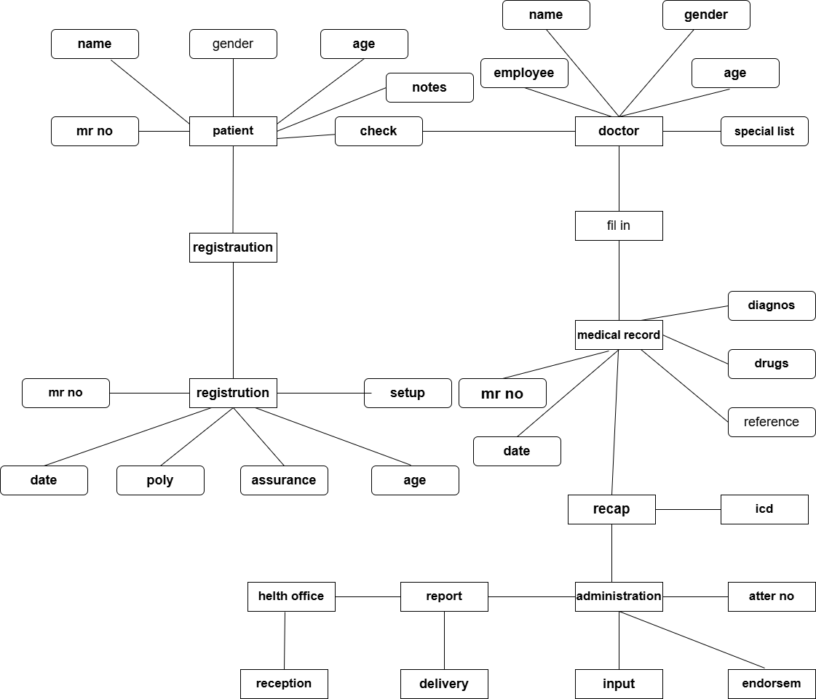

**USECASE DIAGRAM**

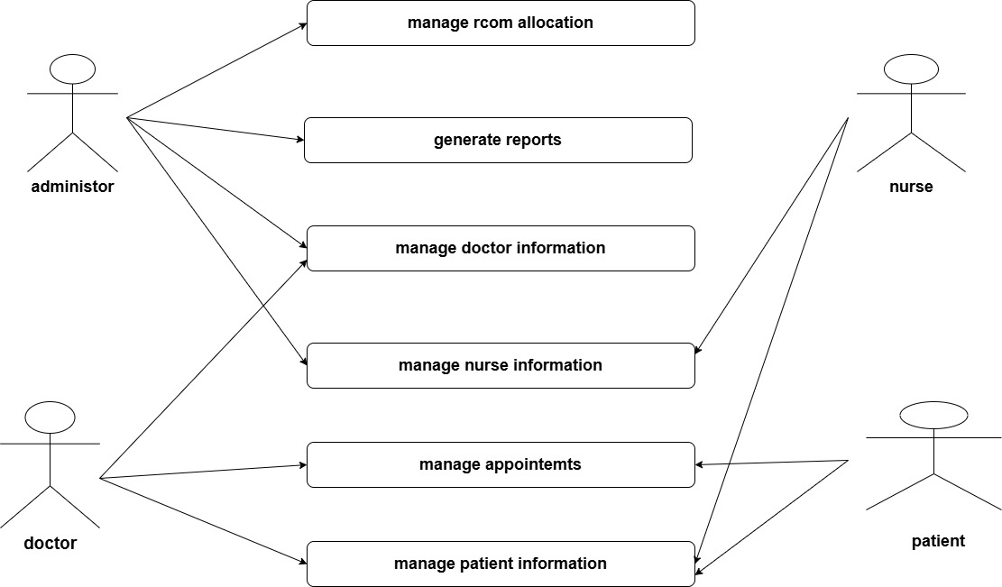

**ACTIVITY DIAGRAM**

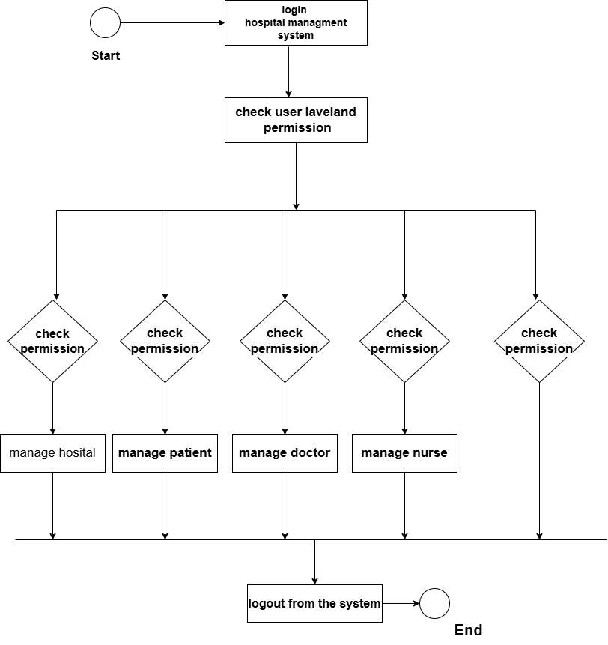

**SEQUENCE DIAGRAM**

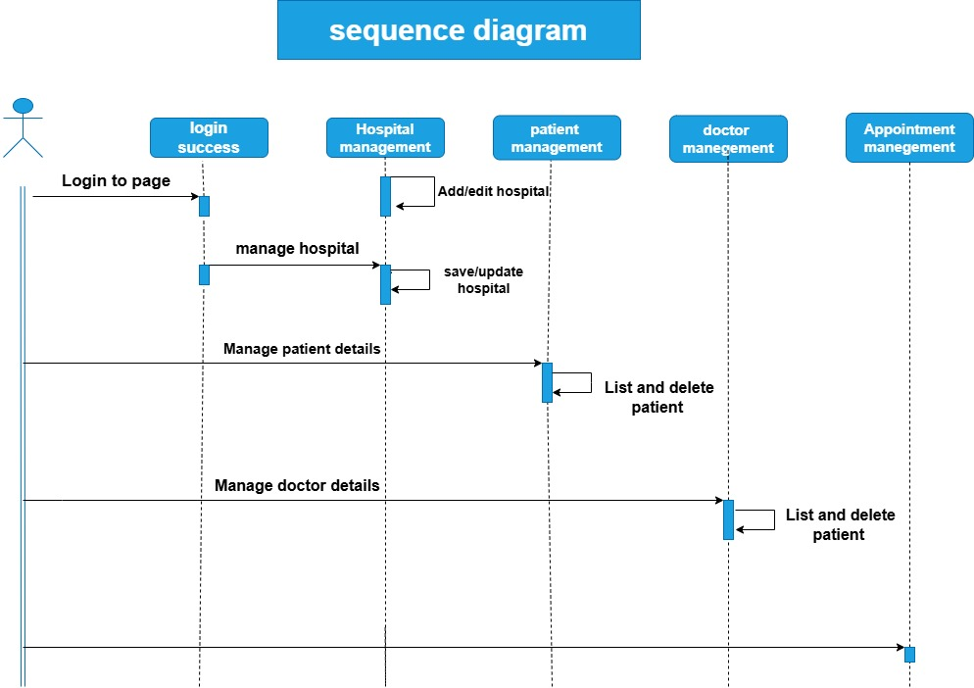

**DFD 0 LEVEL**

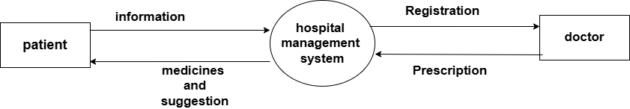

**DFD 1 LEVEL**

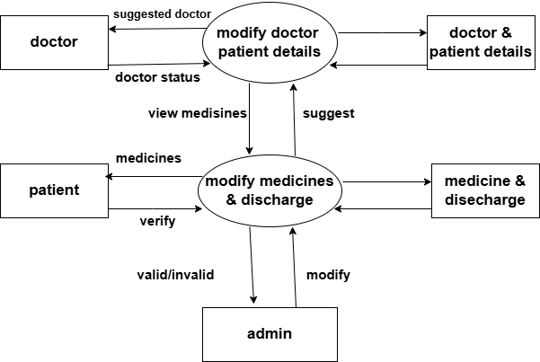

**2 LEVEL DFD**

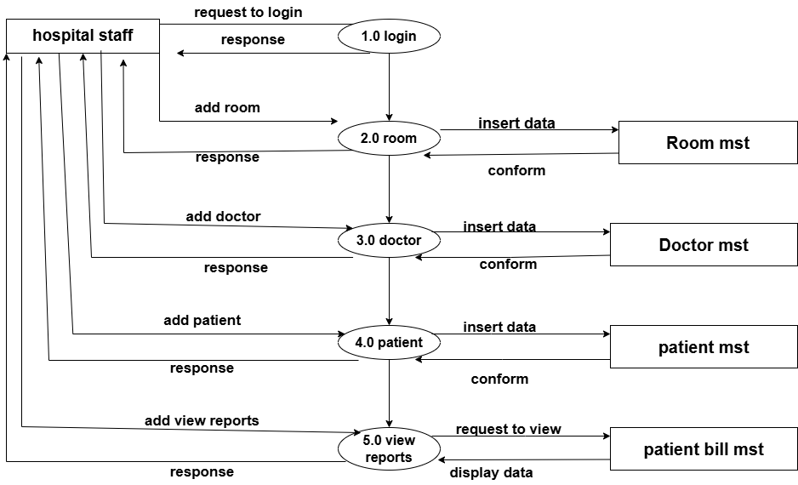

**DATA DICTIONARY**

|  |  |
| --- | --- |
| **NO** | **TABLE NAME** |
| 1 | registration |
| 2 | admin |
| 3 | doctor |
| 4 | appointment |
| 5 | jobapply |
| 6 | patient |
| 7 | schedule |
| 8 | department |
| 9 | staff |

1. **Table Name : -** registration

**No. Column :-** 6

**PRIMARY KEY :-** id

| **Column Name** | **Data Type** | **Size** | **Description** |
| --- | --- | --- | --- |
| id | int(11) | 11 | Auto increment |
| name | varchar(22) | 22 | Full Name |
| number | bigint(10) | 10 | Mobile Number |
| email | varchar(50) | 50 | Email |
| gender | enum | ‘male’, ‘female’, ‘other’ | Enter Gender |
| password | varchar(250) | 250 | Create password |

1. **Table Name : -** admin

**No. Column :-** 10

**PRIMARY KEY :-** id

|  |  |  |  |
| --- | --- | --- | --- |
| **Column name** | **Data Type** | **Size** | **Description** |
| Id | bigint(250) | 250 | Auto Increment |
| file | varchar(200) | 200 | image |
| admin_name | varchar(30) | 30 | Username or Email |
| admin_pass | varchar(25) | 25 | Password |
| lname | varchar(30) | 30 | Last Name |
| dob | varchar(15) | 15 | Date of Birth |
| gender | varchar(20) | 20 | Gender |
| address | varchar(50) | 50 | Address |
| mnumber | bigint(10) | 10 | Mobile Number |
| email | varchar(30) | 30 | Email |

1. **Table Name : -** doctor

**No. Column :-**12

**PRIMARY KEY :-** id

|  |  |  |  |
| --- | --- | --- | --- |
| **Column name** | **Data Type** | **Size** | **Description** |
| Id | int(250) | 250 | Auto Increment |
| dfname | varchar(15) | 15 | First Name |
| dlname | varchar(10) | 10 | Last Name |
| duname | varchar(20) | 20 | User name |
| dnumber | bigint(10) | 10 | Mobile Number |
| demail | varchar(20) | 20 | Email |
| dpassword | varchar(12) | 12 | Password |
| ddob | varchar(15) | 15 | Date of Birth |
| dgender | varchar(5) | 5 | Gender |
| dedu | varchar(15) | 15 | Education |
| ddepart | varchar(20) | 20 | Department |
| daddress | varchar(50) | 50 | Address |

1. **Table Name : -** appointment

**No. Column :-** 9

**PRIMARY KEY :-** id

|  |  |  |  |
| --- | --- | --- | --- |
| **Column name** | **Data Type** | **Size** | **Description** |
| Id | int(250) | 250 | Auto Increment |
| name | varchar(30) | 30 | Enter a Name |
| gender | varchar(30) | 30 | Select Gender |
| number | bigint(10) | 10 | Enter an Phone |
| email | varchar(30) | 30 | Enter an Email |
| Address | varchar(100) | 100 | Address |
| doctor | varchar(23) | 23 | Select Doctor |
| date | varchar(15) | 15 | Enter date |
| note | varchar(85) | 85 | Type in a Massage |

1. **Table Name : -** jobapply

**No. Column :-** 8

**PRIMARY KEY :-** id

|  |  |  |  |
| --- | --- | --- | --- |
| **Column name** | **Data Type** | **Size** | **Description** |
| Id | int(250) | 250 | Auto Increment |
| name | varchar(30) | 30 | Full Name |
| email | varchar(30) | 30 | Enter Your Email |
| number | bigint(10) | 10 | Enter Your Phone Number |
| gender | varchar(10) | 10 | Select Your Gender |
| job role | varchar(15) | 15 | Select Job Role |
| note | varchar(250) | 250 | Additional Note |
| file | varchar(250) | 250 | Upload Resume |

1. **Table Name : -** patient

**No. Column :-** 16

**PRIMARY KEY :-** id

|  |  |  |  |
| --- | --- | --- | --- |
| **Column name** | **Data Type** | **Size** | **Description** |
| Id | int(250) | 250 | Auto Increment |
| fname | varchar(10) | 10 | First Name |
| lname | varchar(10) | 10 | Last Name |
| admit | varchar(20) | 20 | Admit Date |
| uname | varchar(10) | 10 | User Name |
| number | bigint(10) | 10 | Mobile |
| email | varchar(20) | 20 | Email |
| password | varchar(8) | 8 | Password |
| dob | varchar(15) | 15 | Date of Birth |
| gender | varchar(10) | 10 | Gender |
| status | varchar(10) | 10 | Select Status |
| Doctor | varchar(50) | 50 | Department And Doctor |
| address | varchar(50) | 50 | Address |
| amt | Int(10) | 10 | Amount |
| bstatus | varchar(10) | 10 | Select Bill Status |
| ddate | varchar(50) | 50 | Descharge Date |

1. **Table Name : -** schedule

**No. Column :-** 6

**PRIMARY KEY :-** id

|  |  |  |  |
| --- | --- | --- | --- |
| **Column name** | **Data Type** | **Size** | **Description** |
| Id | int(250) | 250 | Auto Increment |
| sname | varchar(50) | 50 | Doctor Name |
| sdepart | varchar(20) | 20 | Select Department |
| sdays | varchar(20) | 20 | Available Days |
| sfrom | Varchar(20) | 20 | From |
| sto | varchar(20) | 20 | to |

1. **Table Name : -** department

**No. Column :-** 3

**PRIMARY KEY :-** id

|  |  |  |  |
| --- | --- | --- | --- |
| **Column name** | **Data Type** | **Size** | **Description** |
| Id | int(250) | 250 | Auto Increment |
| depart | varchar(30) | 30 | Department Name |
| head | varchar(30) | 30 | Department Head |

1. **Table Name : -** staff

**No. Column :-** 10

**PRIMARY KEY :-** id

|  |  |  |  |
| --- | --- | --- | --- |
| **Column name** | **Data Type** | **Size** | **Description** |
| Id | int(250) | 250 | Auto Increment |
| fname | varchar(10) | 10 | First Name |
| lname | varchar(10) | 10 | Last Name |
| number | bigint(10) | 10 | Mobile |
| email | varchar(20) | 20 | Email |
| dob | varchar(15) | 15 | Date of Birth |
| gender | varchar(15) | 15 | Gender |
| Edu | varchar(20) | 20 | Education |
| job | varchar(20) | 20 | Job Role |
| address | varchar(50) | 50 | Address |

**INPUT AND OUTPUT DESIGN**

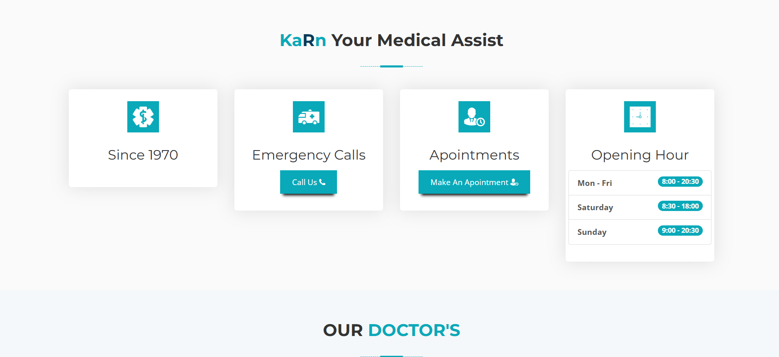**HOME PAGE :-**

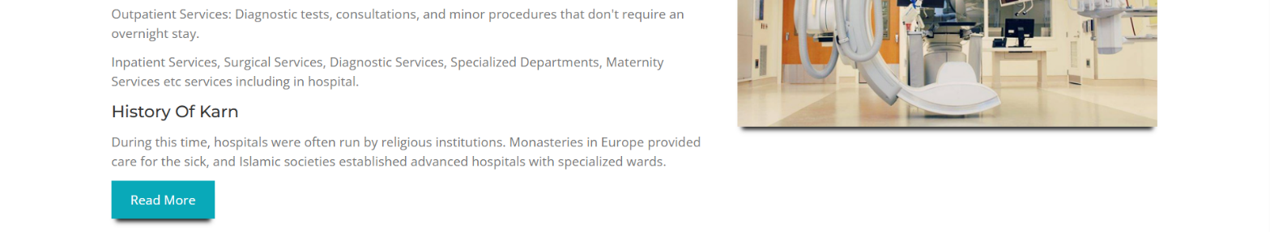**About US Page :-**

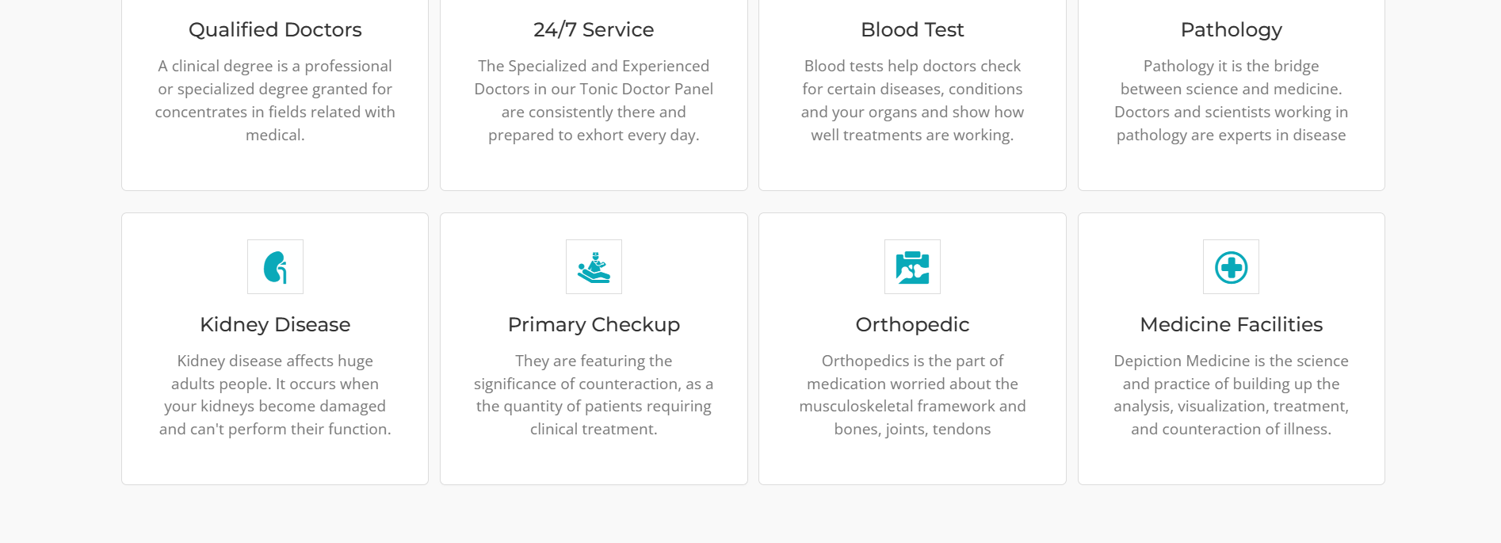**Service Page :-**

**Team Page :-**

**Department Page :-**

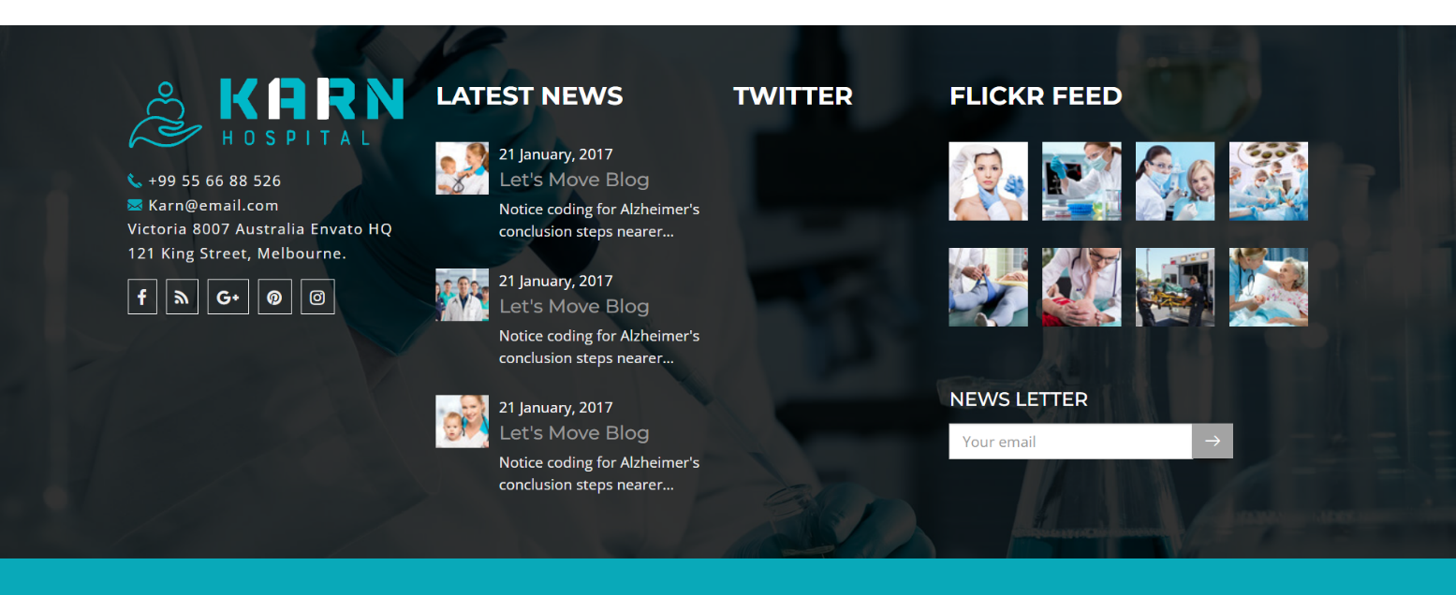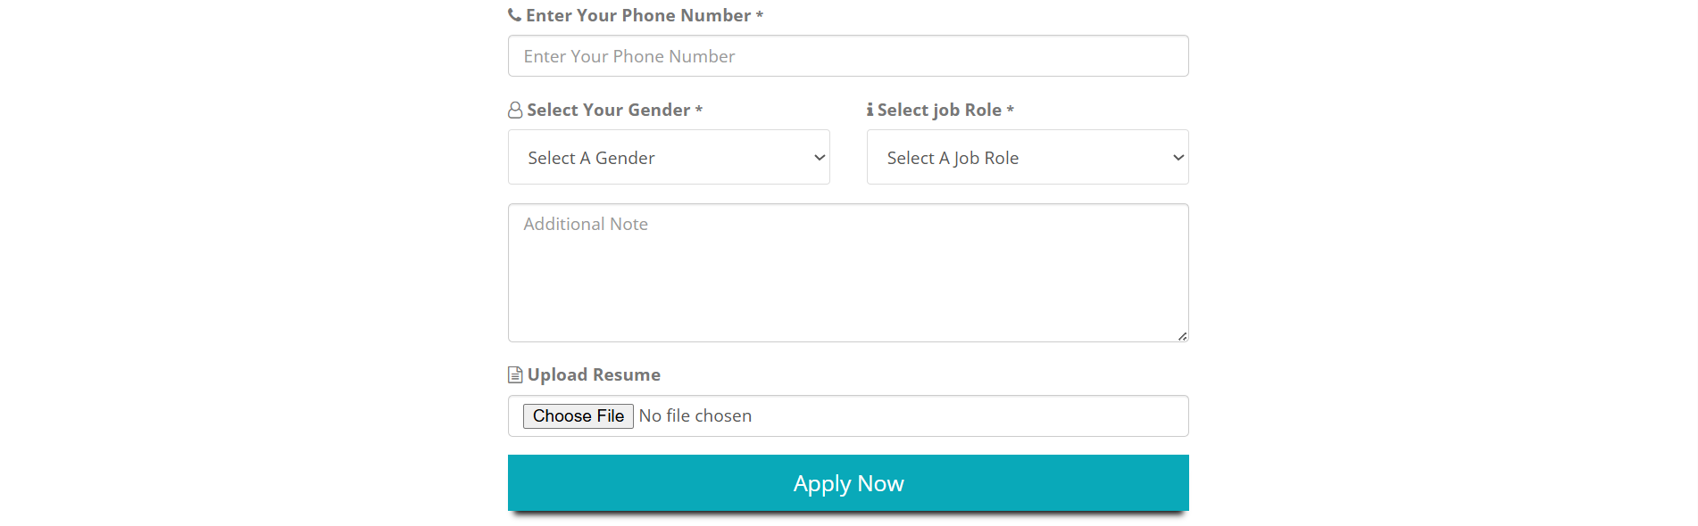**Job Apply Page :-**

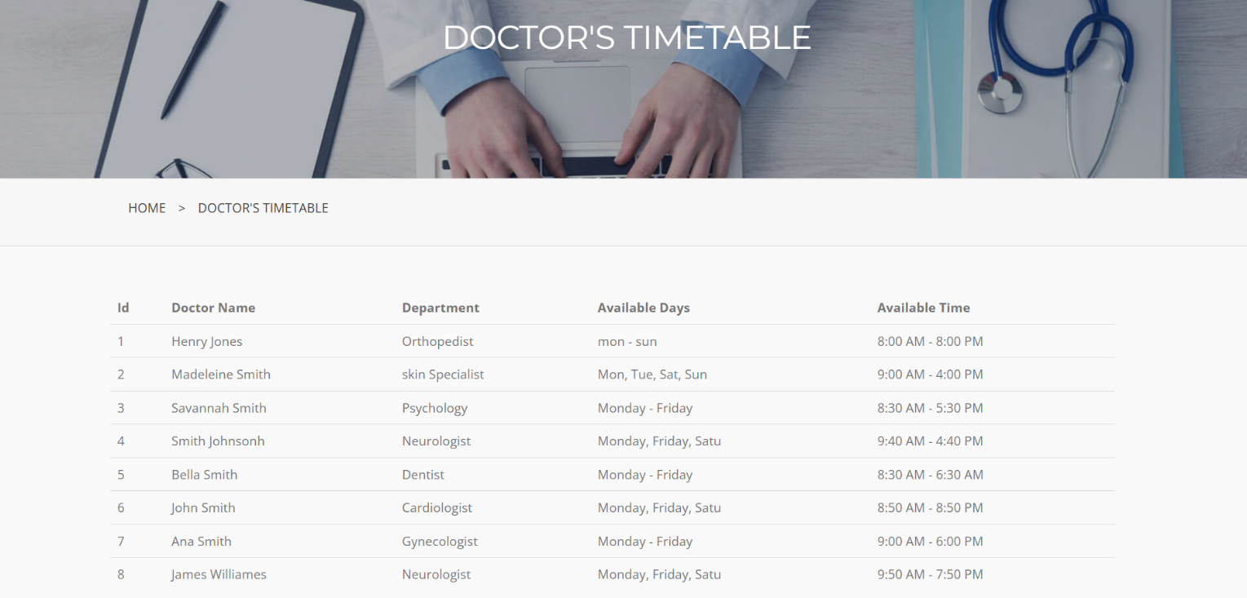**Doctor’s Time Table Page :-**

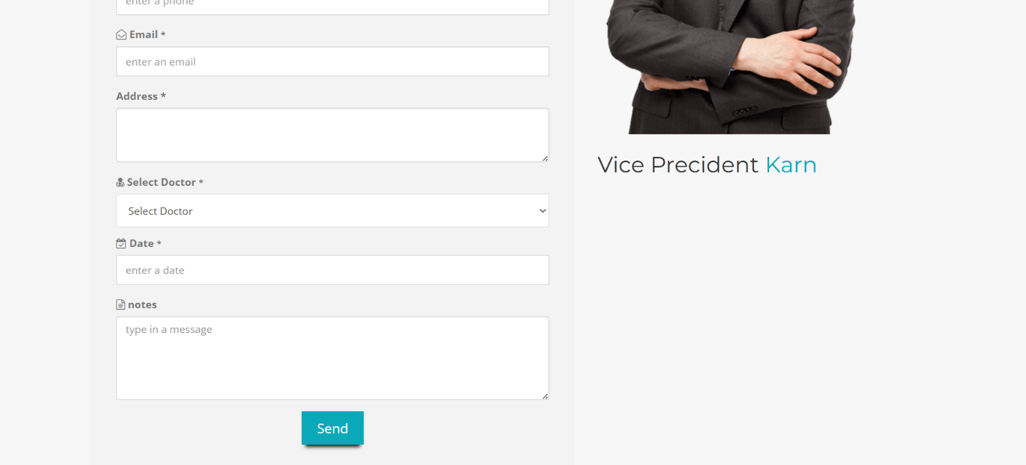**Appointment Page :-**

**Registration Page :-**

**Admin Login Page :-**



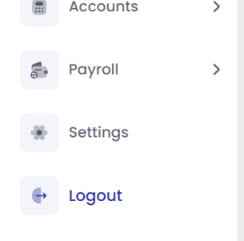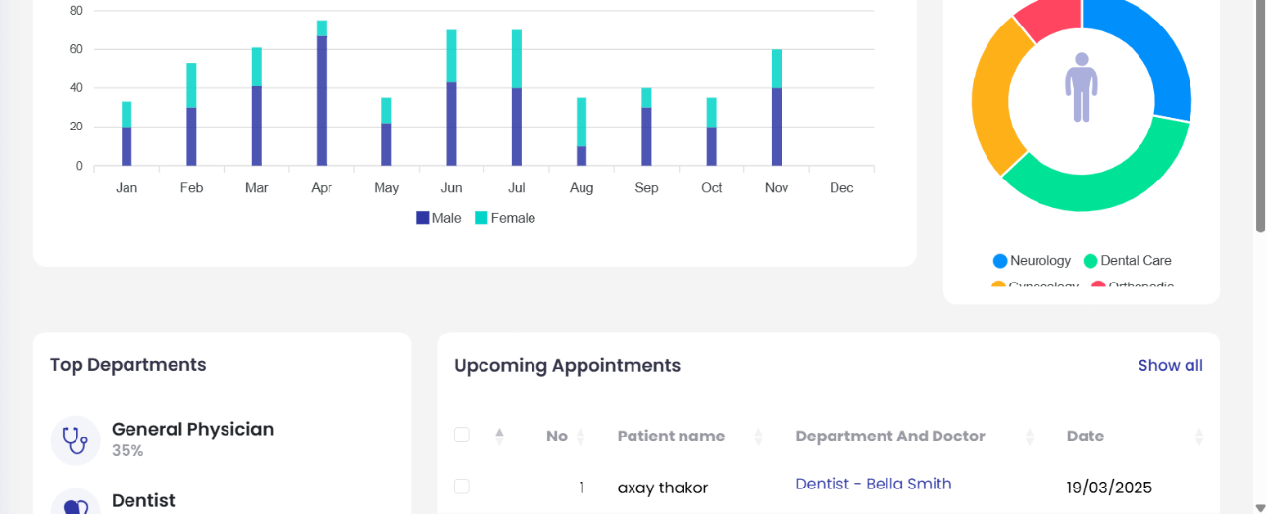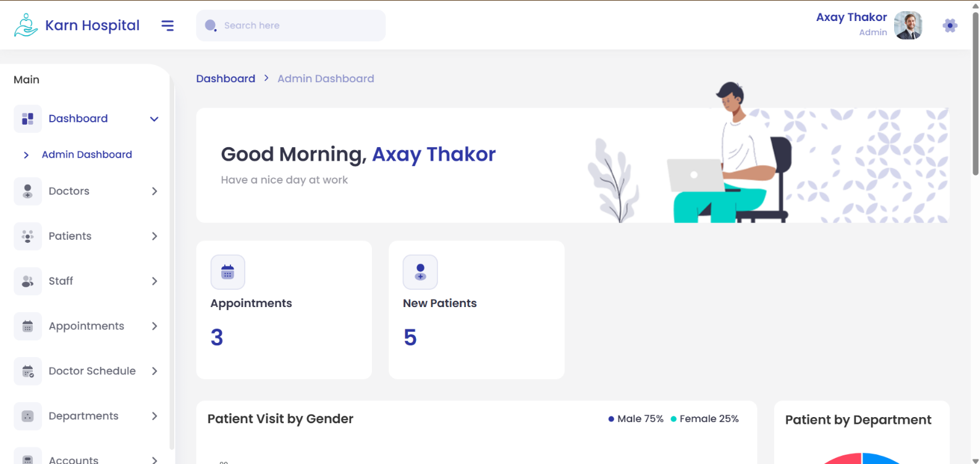**Admin Dashboard Page :-**

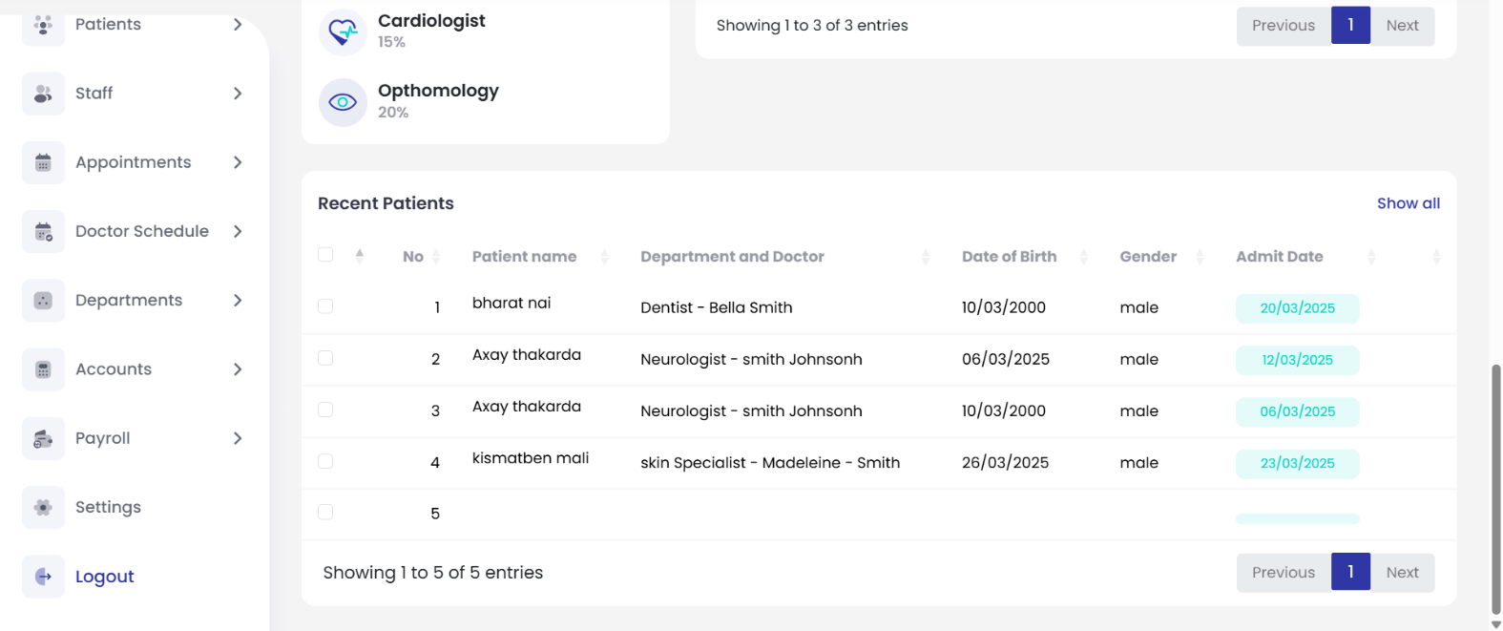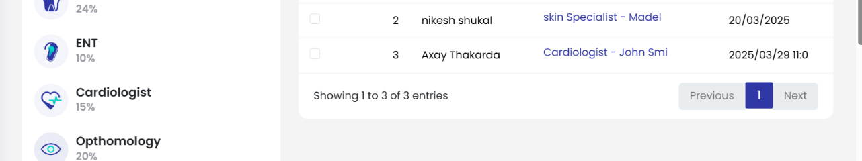

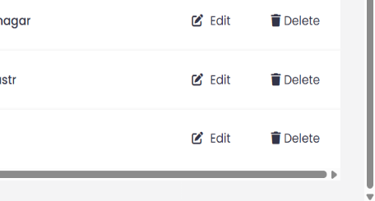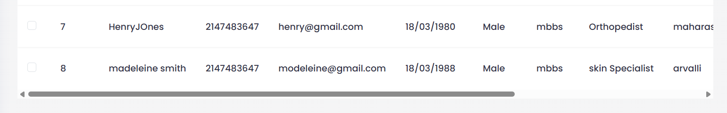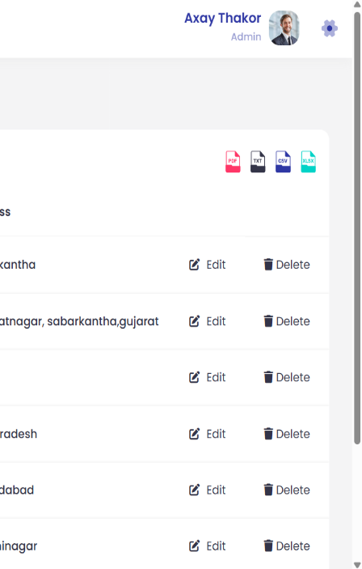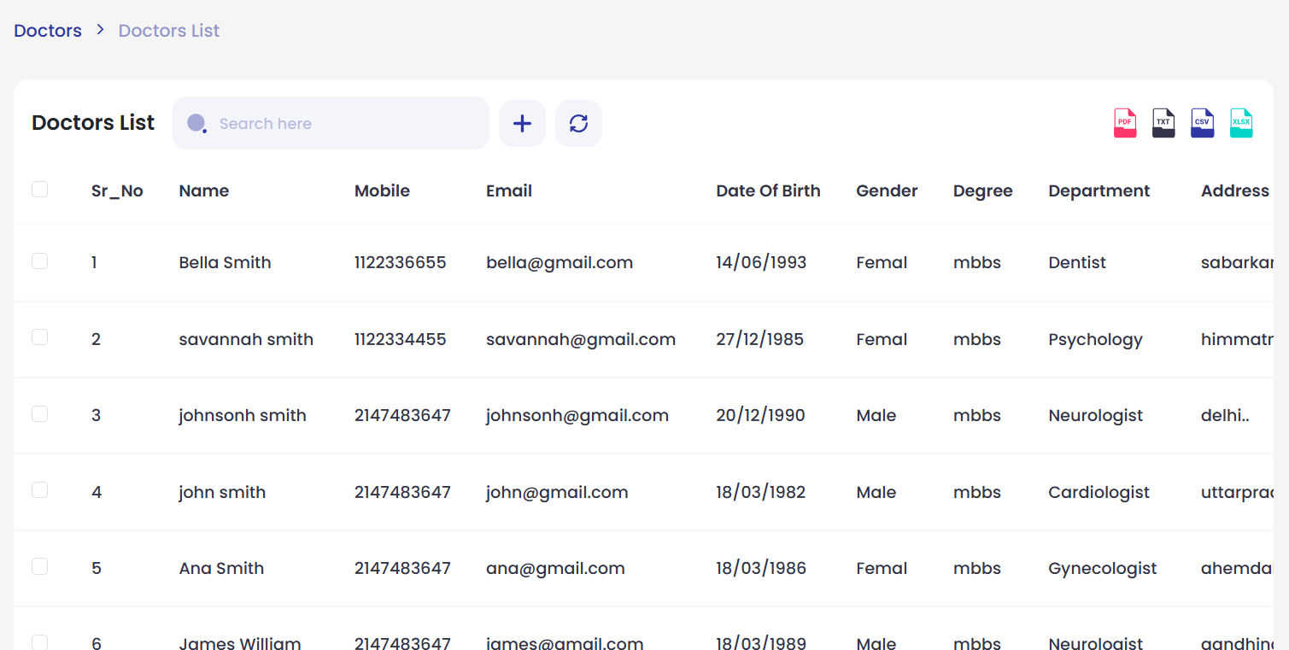**Doctor list Page :-**

**Add Doctor Page :-**

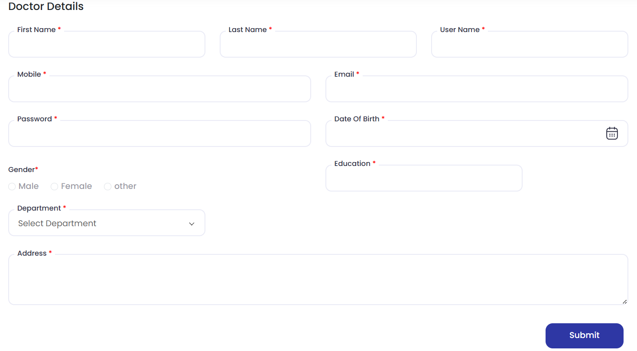

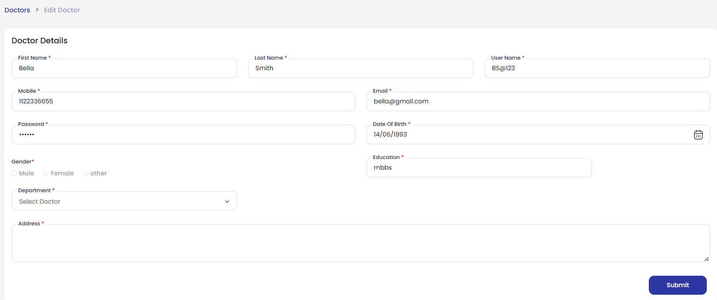**Edit Doctor Page :-**

**Patient list :-**

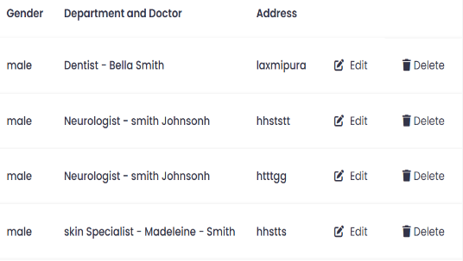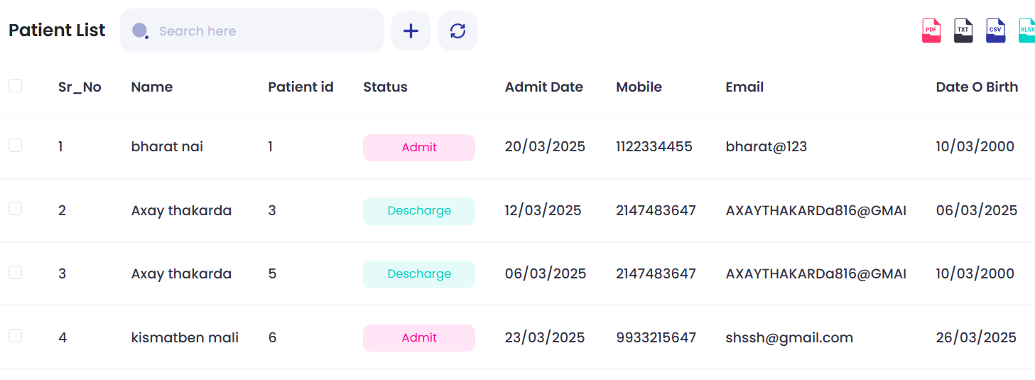

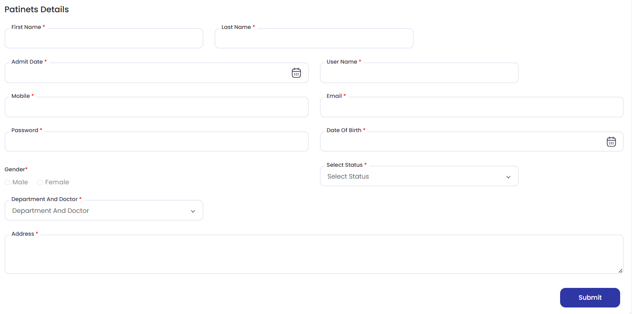**Add Patient page:-**

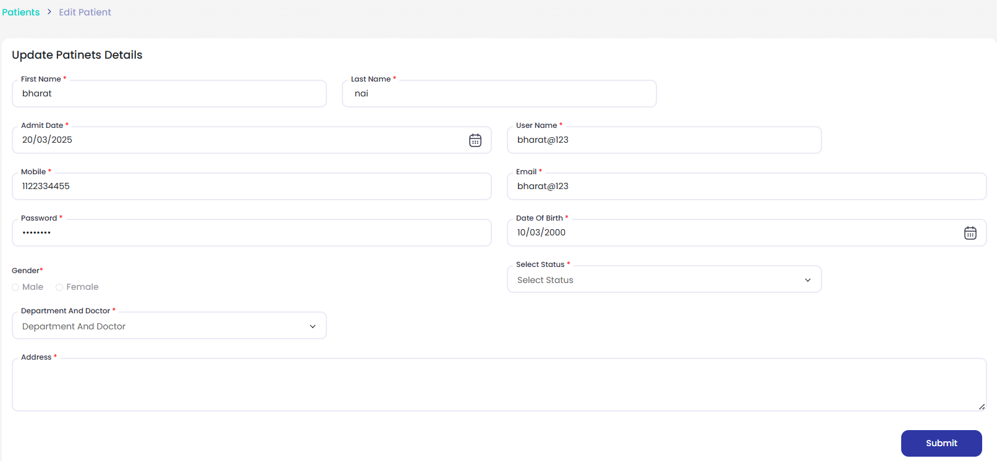**Edit Patient Page :-**

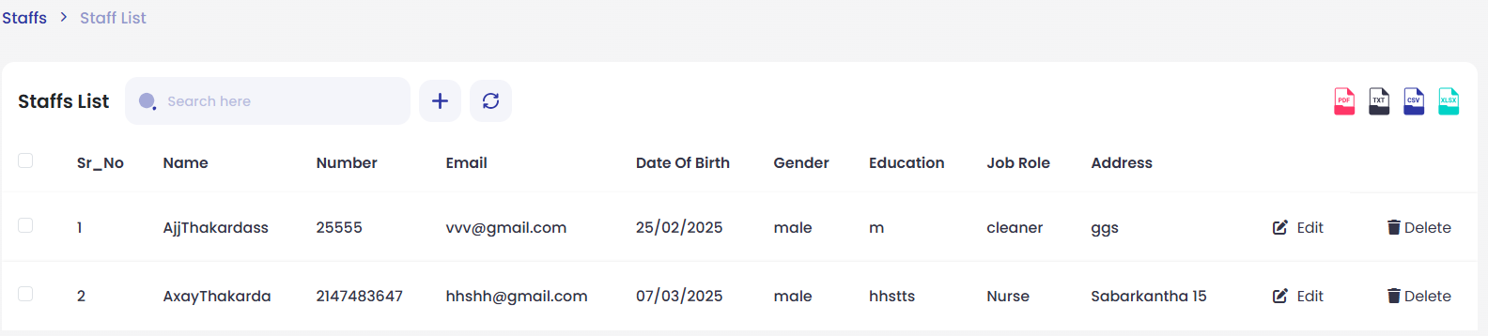**Staff List Page :-**

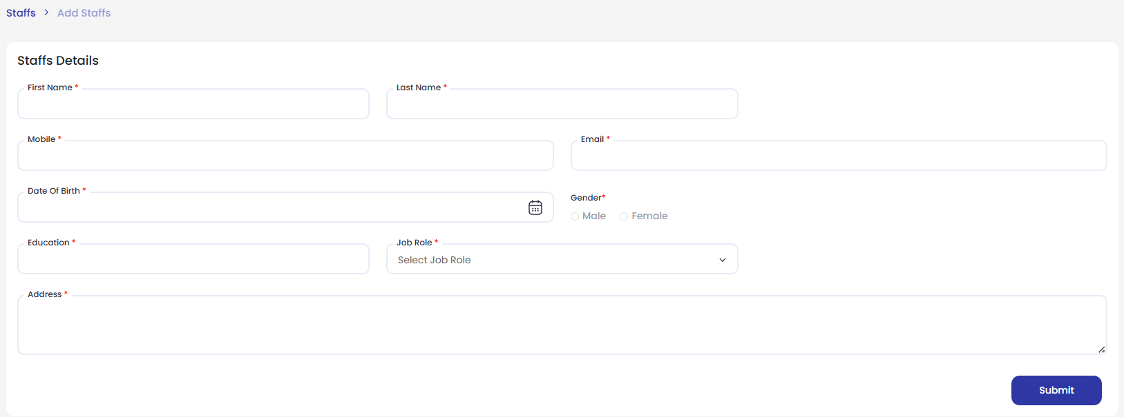**Add Staff Page :-**

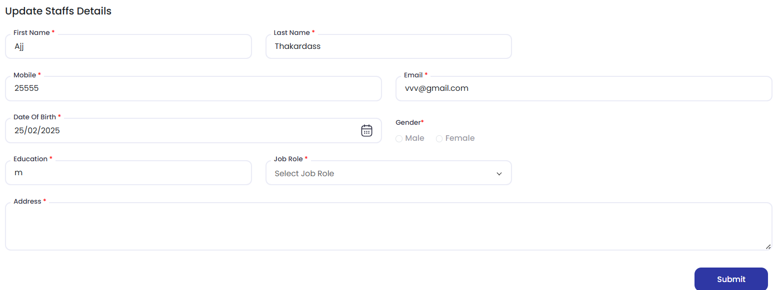**Edit Staff Page :-**

**Appointment Page :-**

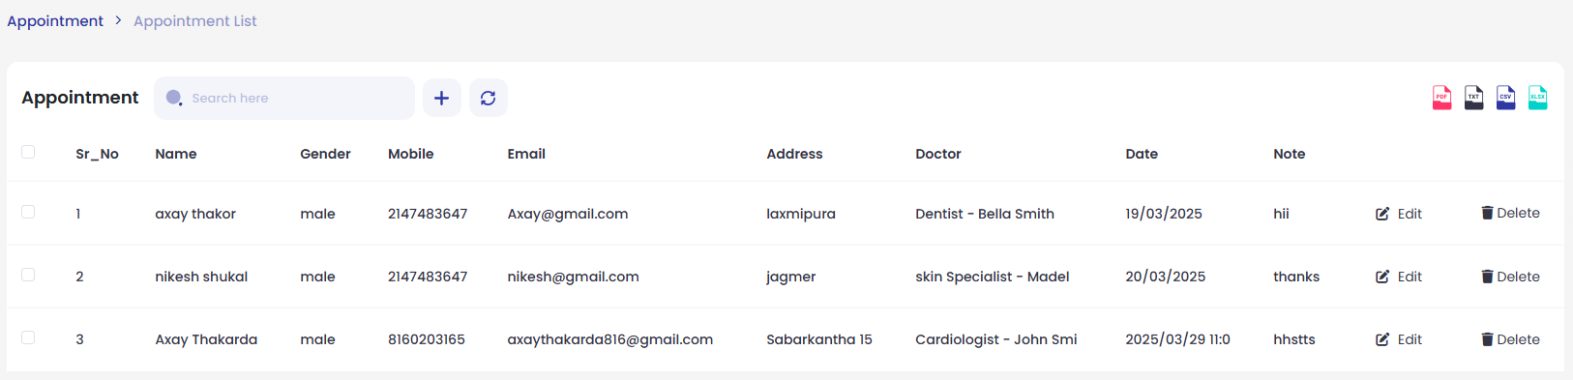

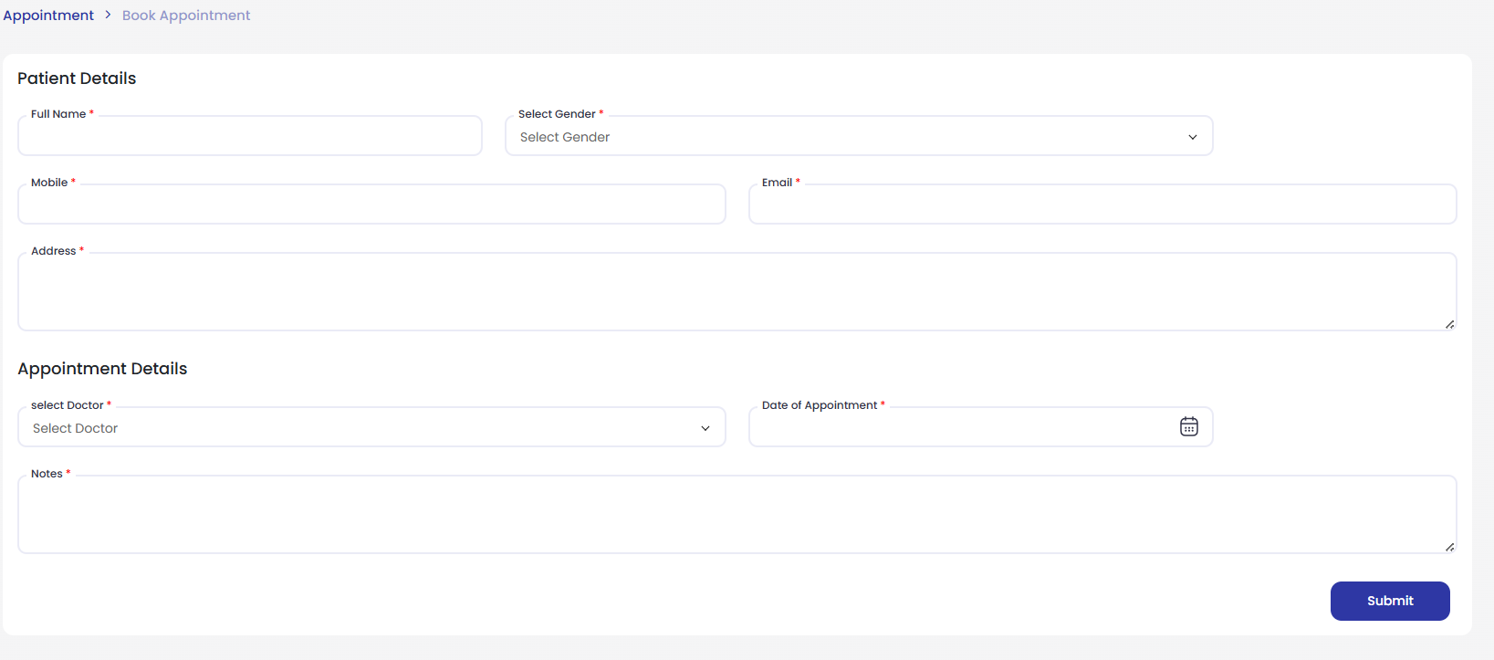**Book Appointment Page :-**

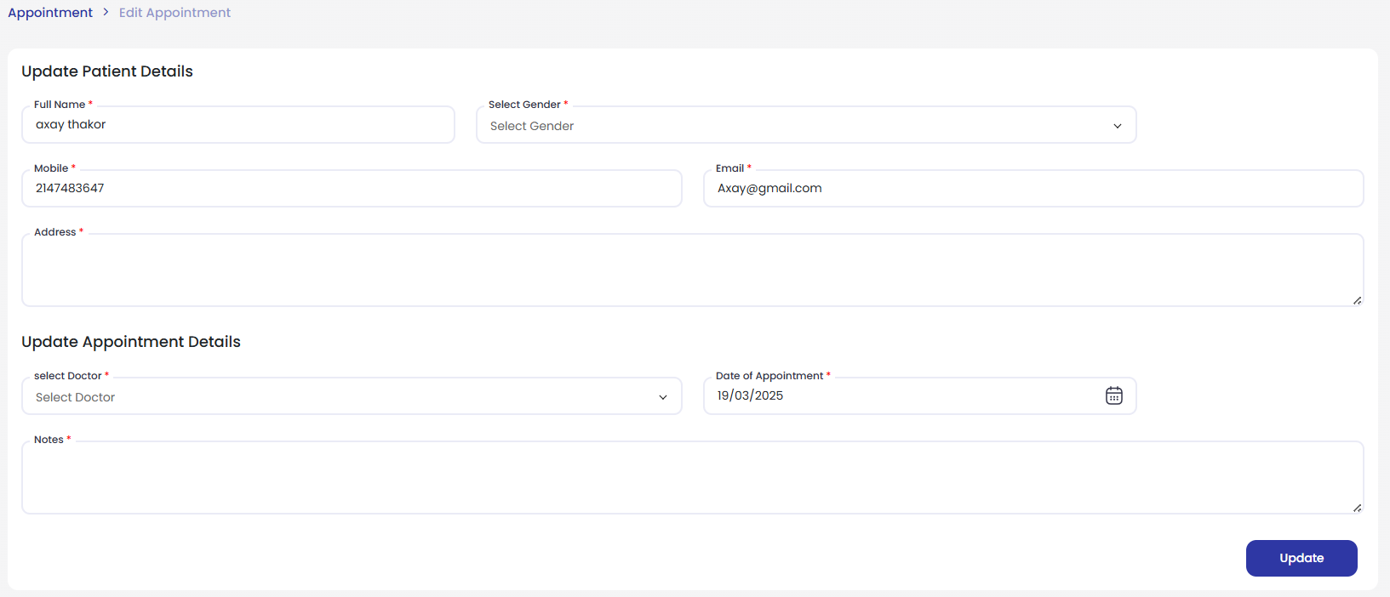**Edit Appointment Page :-**

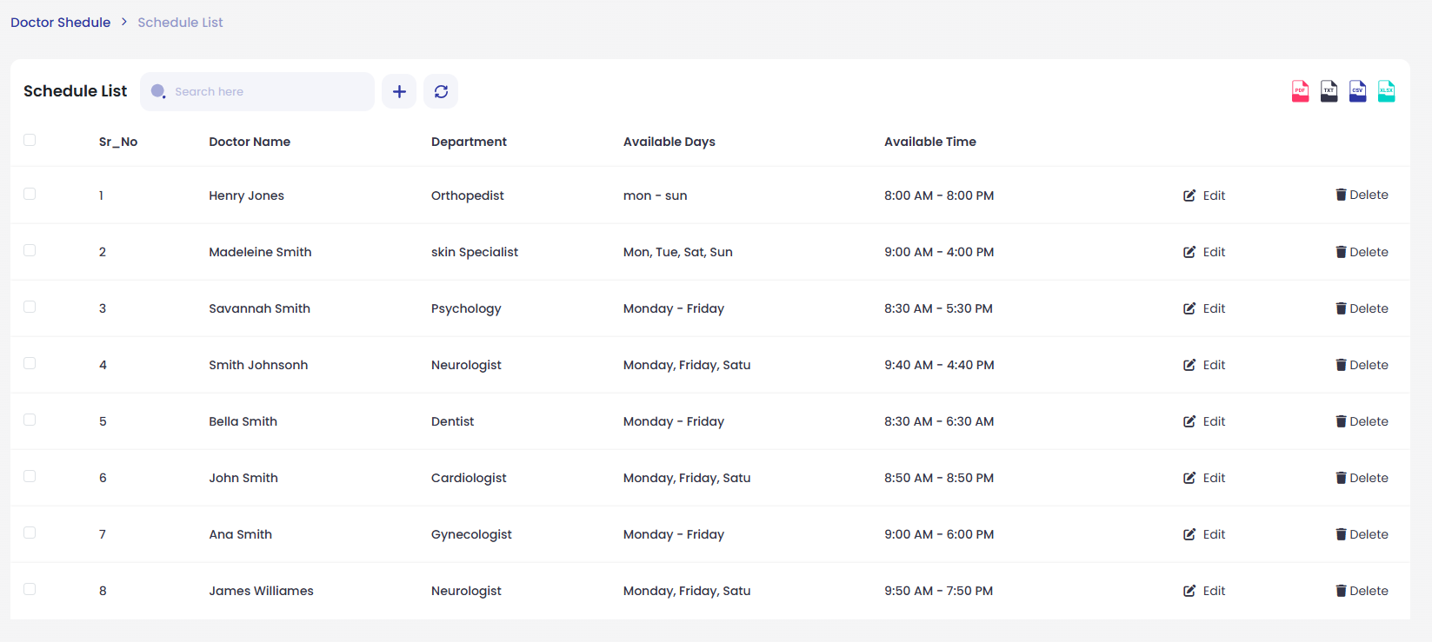**Schedule List :-**

**Add Schedule Page :-**

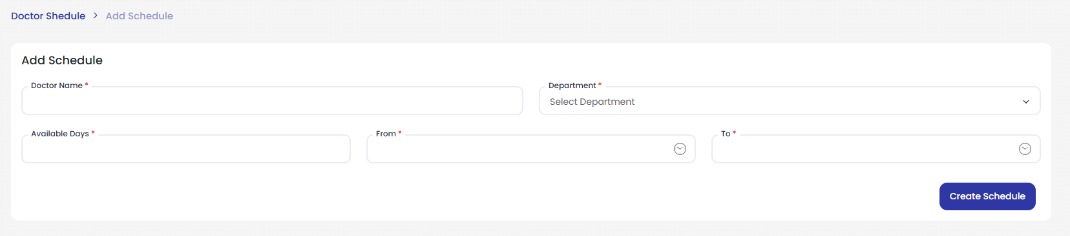

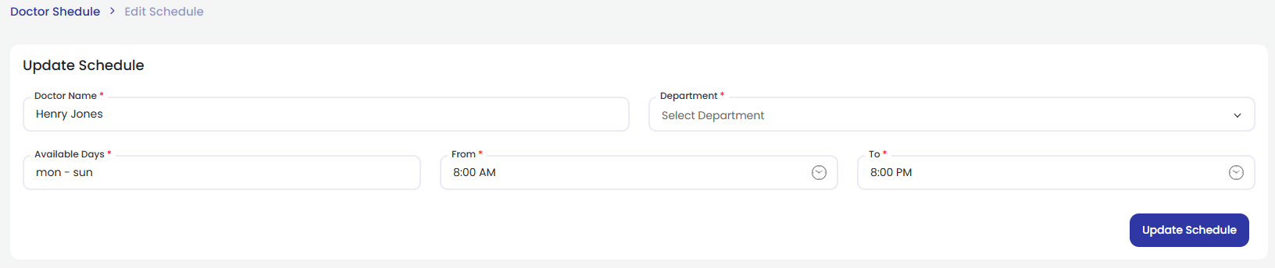**Edit Schedule Page :-**

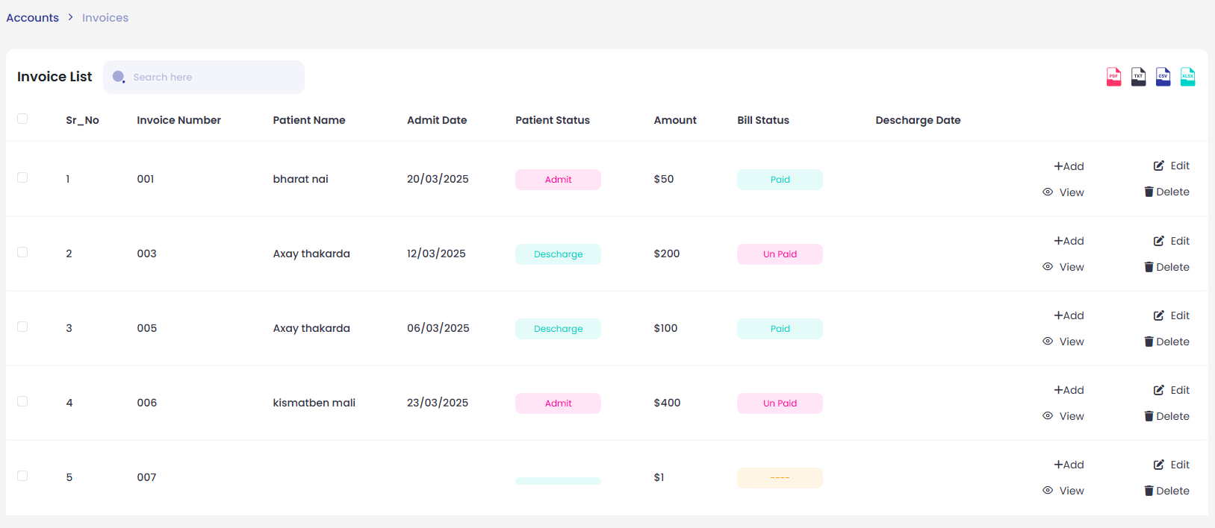**Invoice List Page :-**

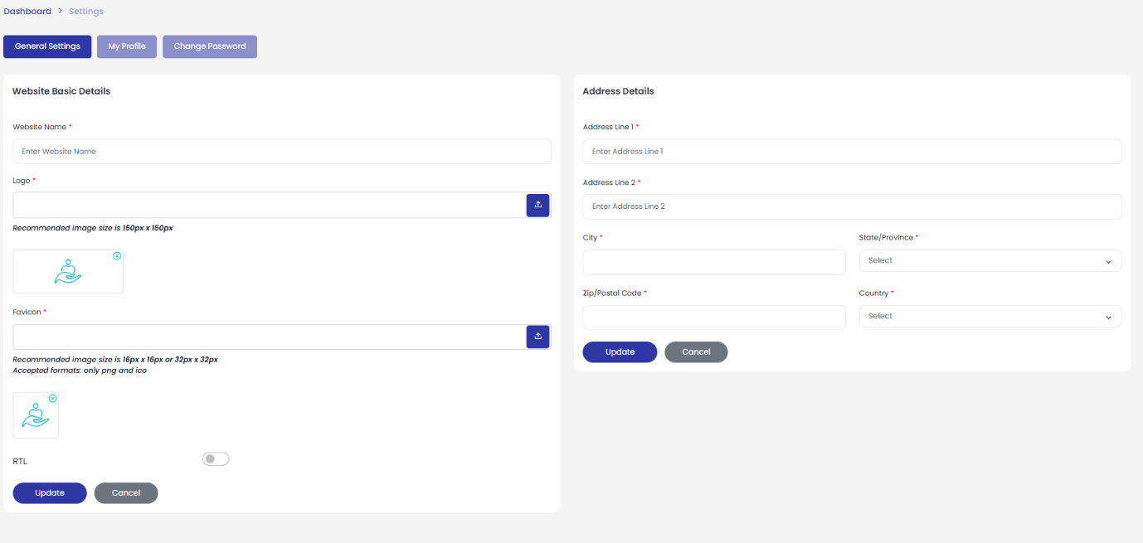**Setting Page :-**

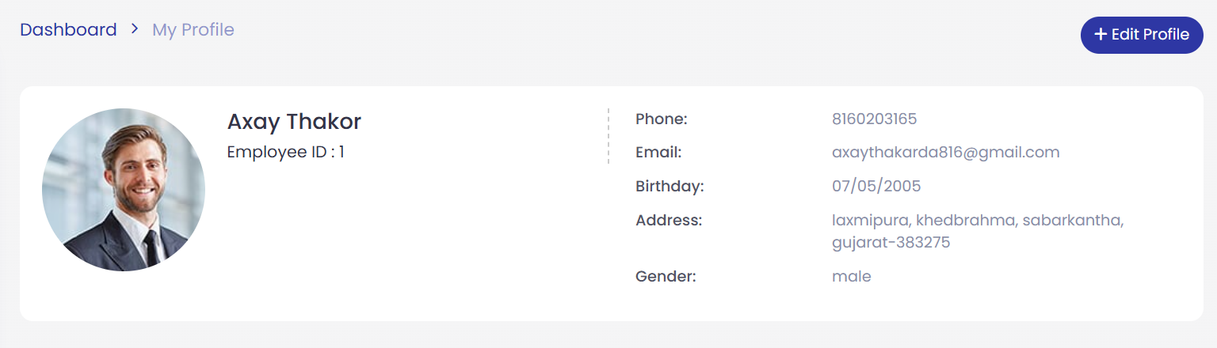**My Profile Page :-**

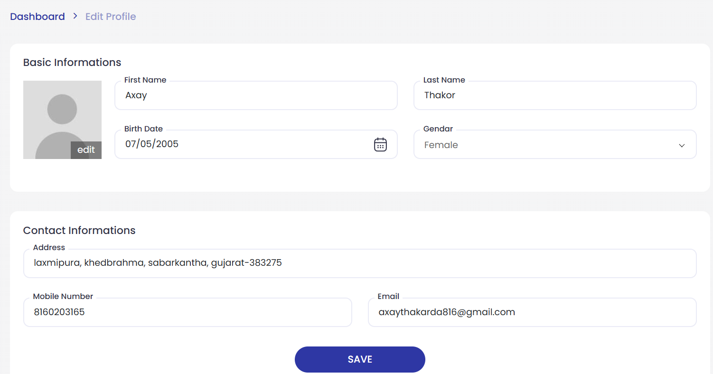**Edit Profile Page :-**

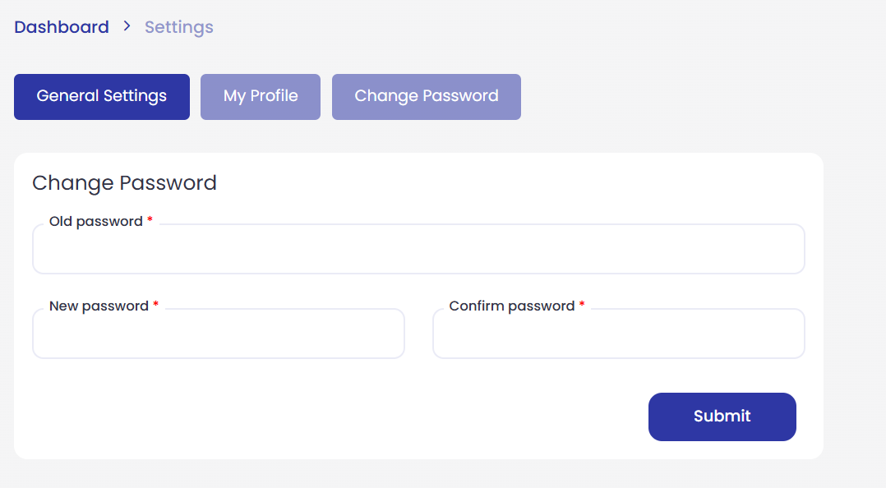**Change Password Page :-**

**TIMELINE CHART**

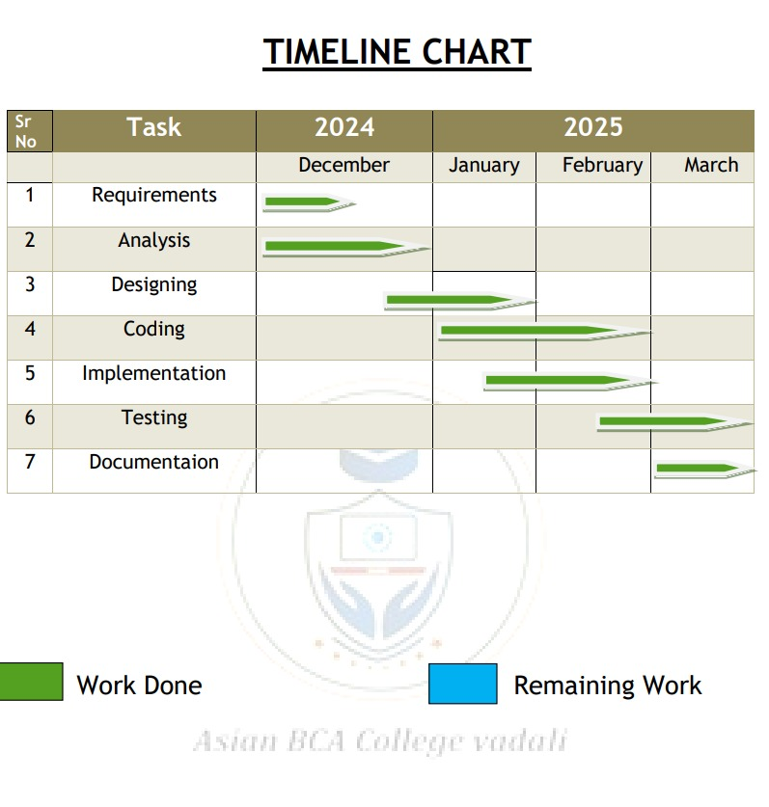

**REFERENCES**

* **Draw.io :-** For Draw Diagram Like E-R , Activity , Sequence , Usecase , DFD.
* Learning PHP, MySQL & JavaScript: With jQuery, CSS & HTML5 by Robin Nixon.
* **Publisher :-** Healthcare Management Systems
* A Guide to Hospital Administration. 2nd ed., Health Press, 2015.
* https://youtu.be/i3FZgZNZ69I?si=E46PizvUuXq6JnZI

**Thank you**